**Course Outcome 1**

**Submitted by : Jomin K Mathew**

**Department of MCA**

**Roll no : 122**

**Semester 1**

**Programe 1**

**Aim :** Model a simple HTML file to demonstrate the use of

different tags.

**Source code :**

**<**html>

<head>

<title>Tags</title>

</head>

<body><br><br>

<h1 align="center">Differnt Tags</h1>

<table align="center" border="1" style="color:black">

<tr>

<th>Tags</th>

<th>Uses</th>

</tr>

<tr>

<th>< html ></th>

<th>Defines an HTML document</th>

</tr>

<tr>

<th>< head ></th>

<th>Information for the document</th>

</tr>

<tr>

<th>< title ></th>

<th>Defines a title for the document</th>

</tr>

<tr>

<th>< body ></th>

<th>Defines the document's body</th>

</tr>

<tr>

<th>< h1 > to < h6 ></th>

<th>Defines HTML headings</th>

</tr>

<tr>

<th>< br ></th>

<th>Inserts a single line break</th>

</tr>

</html>

**Output :**

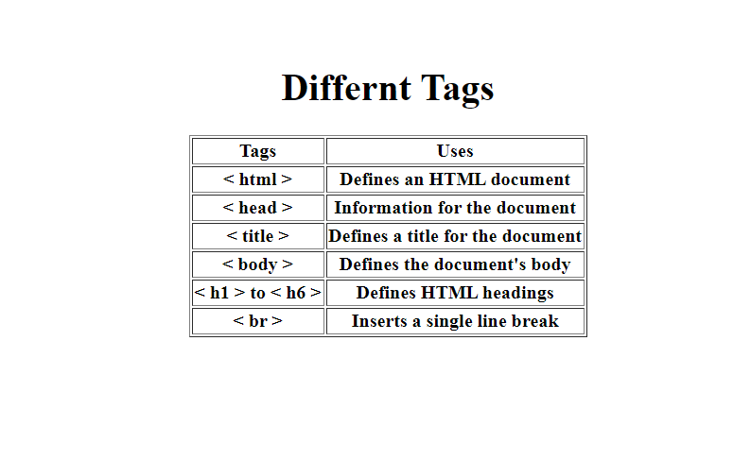

**Programe 2**

**Aim :** Create a HTML file to link to different HTML page

which contains images, tables, and also link within a

page.

**Source code:**

***webpage.html***

<html>

<head>

<title>Jomin K Mathew</title>

</head>

<body background="3.png">

<table>

<br><br><tr><td><td><td><td><td><td><td><td><td><td><td><td><td><td><td><td><td><td><td><td><td><td><td><td><td><td><td><td><td><td><td><td><td><td><td><td><td><td><td><td><td><td><td><td><td><td><td><td><td><td><td><td><td><td><td><td><td><td><td><td><td><td><td><td><td><td><td><td><td><td><td><td><td><td><td><h1><a href="form.html"><button>Profile</button></a></h1></td></td></td></td></td></td></td></td></td></td></td></td></td></td></td></td></td></td></td></td></td></td></td></td></td></td></td></td></td></td></td></td></td></td></td></td></td></td></td></td></td></td></td></td></td></td></td></td></td></td></td></td></td></td></td></td></td></td></td></td></td></td></td></td></td></td></td></td></td></td></td></td></td></td></td>

<td><td><td><td><td><td><td><td><td><td><td><td><td><td><td><td><td><td><td><td><td><td><td><td><td><td><td><td><td><td><td><td><td><td><td><td><td><td><td><td><td><td><td><td><td><td><td><td><td><td><td><h1><a href="Markdetails.html"><button>Mark Details</button></a></h1></td></td></td></td></td></td></td></td></td></td></td></td></td></td></td></td></td></td></td></td></td></td></td></td></td></td></td></td></td></h1></td></td></td></td></td></td></td></td></td></td></td></td></td></td></td></td></td></td></td></td></td></td>

<td><td><td><td><td><td><td><td><td><td><td><td><td><td><td><td><td><td><td><td><td><td><td><td><td><td><td><td><td><td><td><td><td><td><td><td><td><td><td><td><td><td><td><td><td><td><td><td><td><td><td><h1><a href="contactdetail.html"><button>Contact Detail</button></a></h1></td></td></td></td></td></td></td></td></td></td></td></td></td></td></td></td></td></td></td></td></td></td></td></td></td></td></td></td></td></td></h1></td></td></td></td></td></td></td></td></td></td></td></td></td></td></td></td></td></td></td></td></td>

<td><td><td><td><td><td><td><td><td><td><td><td><td><td><td><td><td><td><td><td><td><td><td><td><td><td><td><td><td><td><td><td><td><td><td><td><td><td><td><td><td><td><td><td><td><td><td><td><td><td><td><h1><a href="https://tkmce.ac.in/"><button>TKMCE</button></a></h1></td></td></td></td></td></td></td></td></td></td></td></td></td></td></td></td></td></td></td></td></td></td></td></td></td></td></td></td></td></td></h1></td></td></td></td></td></td></td></td></td></td></td></td></td></td></td></td></td></td></td></td></td></tr></br></br>

</table>

<tr>

<table>

<br><br><br><br><tr><td><td><td><td><h1 style="color:white"> Welcome to my home....</h1></td></td></td></td></tr>

<tr><tr><tr><td><td><td><td><h1 style="color:white"> Come freely. Go safely and</h1></td></td></td></td></tr></tr></tr>

<tr><td><td><td><td><h1 style="color:white"> leave something of the happiness you bring.</h1></tr></td></td></td></td>

</table></tr>

</body>

</html>

***form.html***

<html>

<head>

<title>Jomin K Mathew</title>

</head>

<body style="background-color:#3399ff;">

<table align="right">

<td><td><td><td><td><td><td><td><td><td><td><td><td><td><td><td><td><td><td><td><td><td><td><td><td><td><td><td><td><td><td><td><h1><a href="webpage.html"><button>Home</button></a></h1></td></td></td></td></td></td></td></td></td></td></td></td></td></td></td></td></td></td></td></td></td></td></td></td></td></td></td></td></td></td></h1></td></td></tr></table>

<table><br><br><h1 align="center" style="color:black">Profile</h1></table>

<p align="center">

<img src="jomin.jpg" width="100" height="130"></p>

<table align="center">

<td>Name :</td>

<td>JOMIN K MATHEW</td>

<tr>

<td>Department :</td>

<td>MCA</td>

</tr>

<tr>

<td>Gender :</td>

<td>Male</td>

</tr>

<tr>

<td>Father's Name :</td>

<td>MATHEW K</td>

</tr>

<tr>

<td>Mother's Name :</td>

<td>SHYNI T JOHN</td>

</tr>

<tr>

<td>Address :</td>

<td><form>Palavila Kizhekkathil Veedu</form></td>

</tr>

<tr>

<td>Blood Group :</td>

<td style="color:red">O+</td>

</tr>

<tr>

<td>Email :</td>

<td style="color:darkblue">jominachu001@gmail.com</td>

</tr>

<tr>

<td>Phone no :</td>

<td style="color:darkblue"> +91 7558805897

</td>

</tr>

</table>

</body>

</html>

***Contactdetail.html***

<html>

<head>

<title>Jomin K Mathew</title>

</head>

<body style="background-color:#3399ff;">

<table align="right">

<td><td><td><td><td><td><td><td><td><td><td><td><td><td><td><td><td><td><td><td><td><td><td><td><td><td><td><td><td><td><td><td><h1><a href="webpage.html"><button>Home</button></a></h1></td></td></td></td></td></td></td></td></td></td></td></td></td></td></td></td></td></td></td></td></td></td></td></td></td></td></td></td></td></td></h1></td></td></tr></table>

<table><br><br><h1 align="center" style="color:black">Contact Detail</h1></table>

<form>

<table align="center">

<td><h4>Address :</h4></td>

<td>Palavila Kizhekkathil Veedu

<br>Kulakkada East P.O

<br>Kottarakka, Kollam,

<br>Kerala</td>

<tr>

<td><h4>Email :</h4></td>

<td style="color:darkblue">jominachu001@gmail.com</td>

</tr>

<tr>

<td><h4>Phone no :</h4></td>

<td style="color:darkblue">+91 7558805897

</td>

</tr>

</table>

</form>

</body>

</html>

***markdetail.html***

<html>

<head>

<title>Jomin K Mathew</title>

</head>

<body style="background-color:#3399ff;">

<table align="right">

<td><td><td><td><td><td><td><td><td><td><td><td><td><td><td><td><td><td><td><td><td><td><td><td><td><td><td><td><td><td><td><td><h1><a href="webpage.html"><button>Home</button></a></h1></td></td></td></td></td></td></td></td></td></td></td></td></td></td></td></td></td></td></td></td></td></td></td></td></td></td></td></td></td></td></h1></td></td></tr></table>

<table><br><br><h1 align="center" style="color:black">Mark Details</h1></table>

<form>

<table border="5" style="color:black" align="center">

<tr>

<th>Semester</th>

<th>CGPA</th>

</tr>

<tr>

<td>1st Semester</td>

<td>6.2</td>

</tr>

<tr>

<td>2nd Semester</td>

<td>6.3</td>

</tr>

<tr>

<td>3rd Semester</td>

<td>6.01</td>

</tr>

<tr>

<td>4th Semester</td>

<td>6.52</td>

</tr>

<tr>

<td>5th Semester</td>

<td>6.7</td>

</tr>

<tr>

<td>6th Semester</td>

<td>6.01</td>

</tr>

</table>

</form>

</body>

</html>

**Output :**

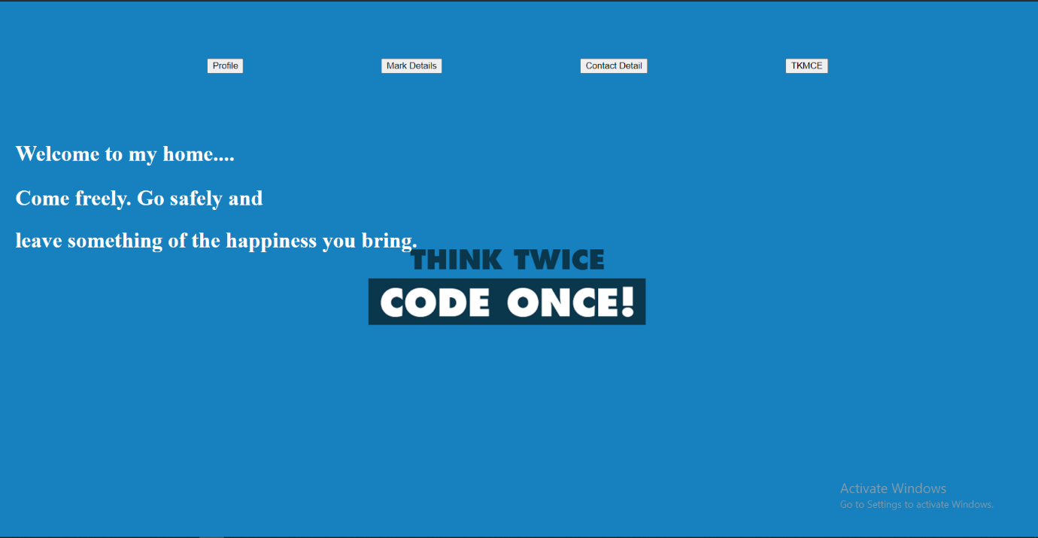

**Programe 3**

**Aim :** Create a HTML page with different types of frames

such as floating frame, navigation frame & mixed

frame.

**Source code :**

***mainpage.html***

<html>

<body>

<a href="navigationframe.html" target="two">Navigation Frame</a><br>

<a href="floatingframe.html" target="two">Floating Frame</a><br>

<a href="mixedframe.html" target="two">Mixed Frame</a><br>

</body>

</html>

***navigationpage.html***

<html>

<frameset cols="25%,*" scrolling="no" noresize>

<frame name="one" src="mainPage.html">

</frame>

<frame name="two" ></frame>

<frameset rows="30%,*">

<frame src="a.jpg">

</frame></frameset>

</html>

***mixedframe.html***

<html>

<frameset cols="30%,*">

<frame src="c.jpg" height="100" width="100" ></frame>

<frameset rows="50%,*">

<frame src="b.jpg" autostart="true">

<frame src="d.jpg" >

</frameset> </frameset>

</html>

***floatingframe.html***

<html>

<body>

<p> Floating Frame

<iframe src="d.jpg" height="500" width="750">

</iframe>

<iframe src="MainPage.html" height="50%" width="50%">

</iframe>

</body>

</html>

**Output :**

**Navigation frame :**

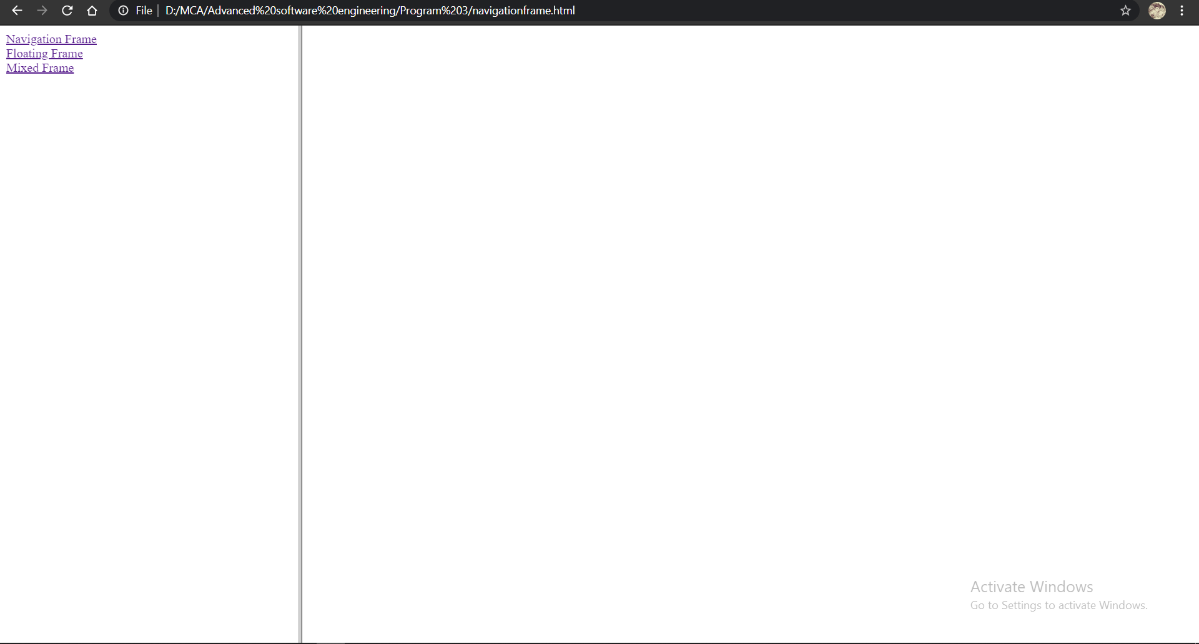

**Floating Frame :**

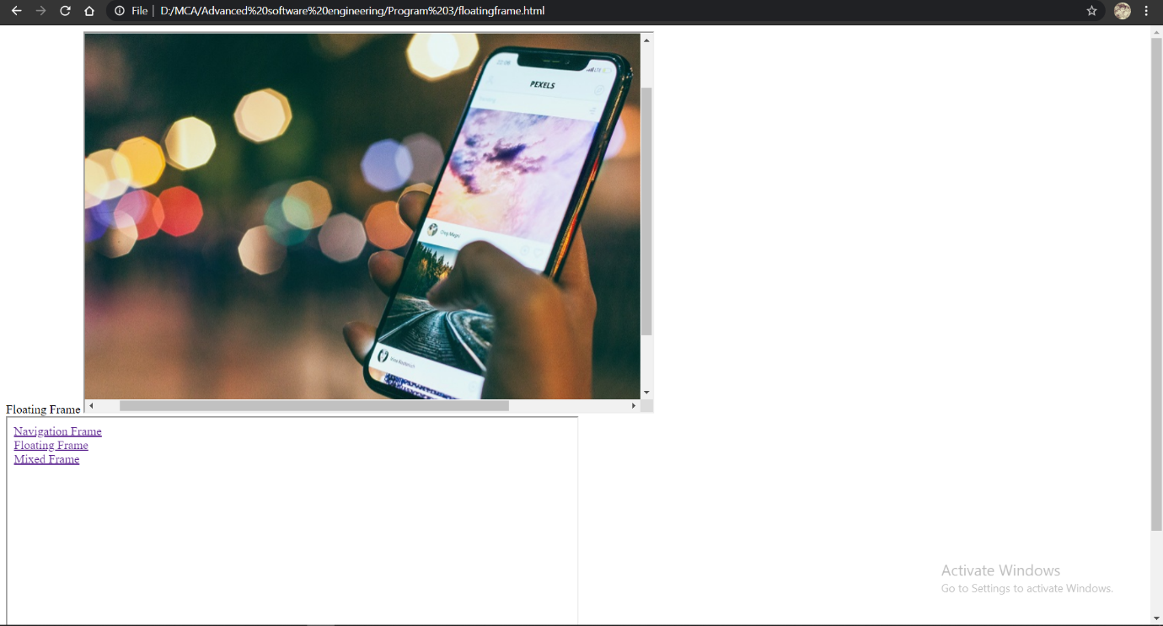

**Mixed Frame :**

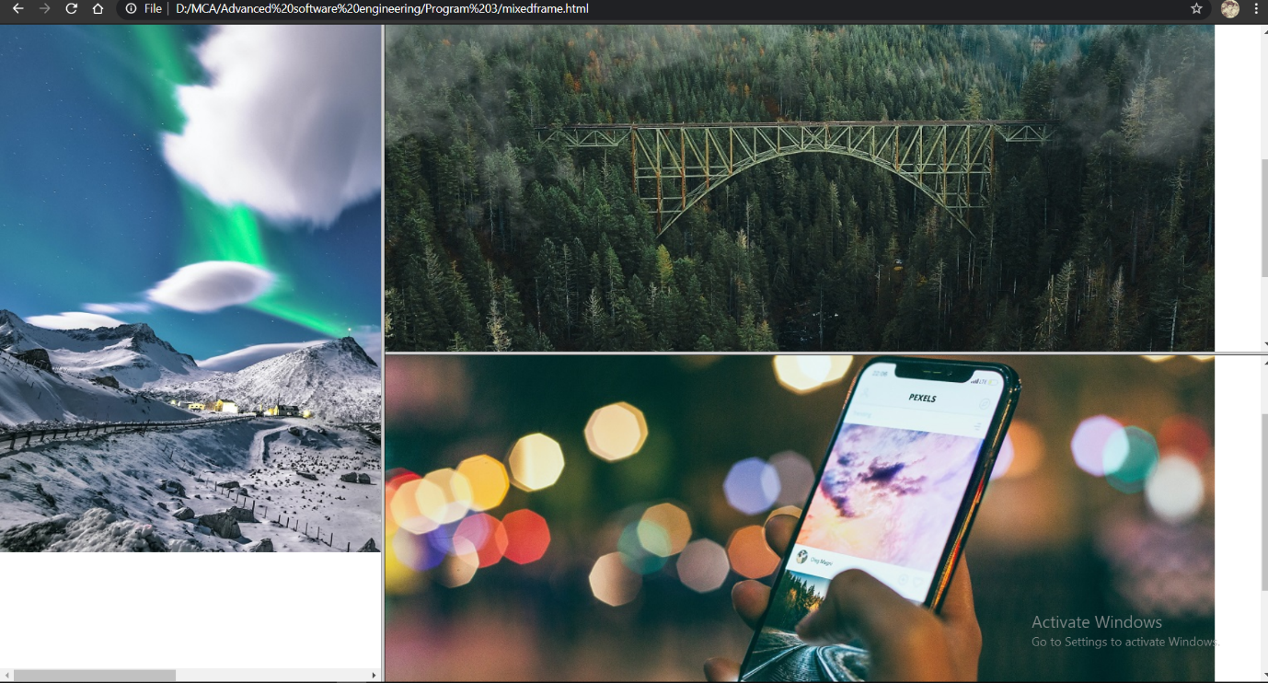

**Program 4**

**Aim :** Analyze CSS by applying the different styles using

inline, external & internal style sheets in a HTML file.

**Source code :**

***form.html***

<html>

<head>

<link rel="stylesheet" type="text/css" href="external.css">

<style>

form

{

*color: black;*

*font-weight:bold;*

*font-family*: Helvetica, sans-serif;

}

</style>

<title>Jomin K Mathew</title>

</head>

<body style="background-color:#3399ff;">

<h1 align="center" style="background: red">Form</h1>

<form align="center">

<label for="fname" > Name: </label>

<input type="text" id="fname" name="fname"><br><br>

<label for="roll">Roll no: </label>

<input type="text" id="roll" name="roll"><br><br>

<label >Gender: </label>

<input type="radio" id="male" name="gender" value="male">

<label for="male">Male</label>

<input type="radio" id="female" name="gender" value="female">

<label for="female">Female</label>

<input type="radio" id="other" name="gender" value="other">

<label for="other">Other</label><br><br>

<label for="dep">Department: </label>

<select name="dep" id="dep">

<option >B-TEC</option>

<option >B.Sc</option>

<option >MCA</option>

<option >M-TEC</option>

</select><br><br>

<label for="add">Address: </label>

<textarea name="add" id="add"></textarea><br><br>

<a ><button >Submit</button></a>

</a>

</form>

</body>

</html>

***external.css***

button

{

background: yellow;

}

**Output :**

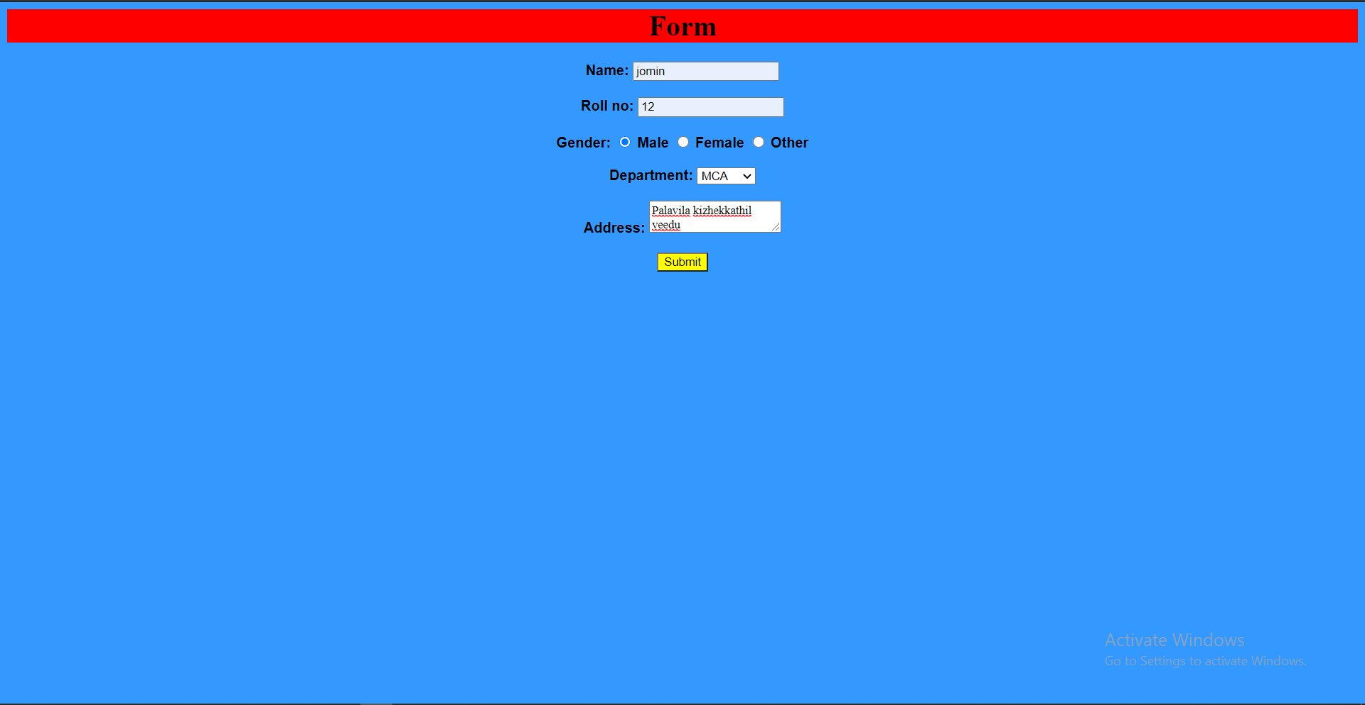

**Program 5**

**Aim :** Demonstrate a registration form using HTML.

**Source code :**

***registrationform.html***

<html>

<head>

<link rel="stylesheet" type="text/css" href="rgform.css">

<title>Jomin K Mathew</title>

</head>

<body style="background-color:" background="1.jpg"> <br><br>

<h1 align="center" style="background: ">Registration Form</h1>

<br>

<form align="center">

<label for="fname" > Name: </label>

<input type="text" id="fname" name="fname"><br><br>

<label for="roll">Institution : </label>

<input type="text" id="roll" name="roll"><br><br>

<label for="roll">E-mail : </label>

<input type="text" id="roll" name="roll"><br><br>

<label >Gender: </label>

<input type="radio" id="male" name="gender" value="male">

<label for="male">Male</label>

<input type="radio" id="female" name="gender" value="female">

<label for="female">Female</label>

<input type="radio" id="other" name="gender" value="other">

<label for="other">Other</label><br><br>

<label for="roll">Address : </label>

<input type="text" id="roll" name="roll"><br><br>

<label for="roll">Phone no : </label>

<input type="text" id="roll" name="roll">

<br><br>

<a ><button >Submit</button></a>

</a>

</form>

</body>

</html>

***rgform.css***

button

{

background: lightgreen;

}

form

{

font-weight:bold;

font-family: Helvetica, sans-serif;

color: black;

}

**Output :**

